วิทยาลัยพยาบาลบรมราชชนนี สุรินทร์
ทะเบียนรายชื่อหนังสือทางการพยาบาล สาขาการพยาบาลสูติศาสตร์ ฉบับภาษาอังกฤษ
**********
สถิติ: หนังสือการพยาบาลสูติศาสตร์-2554 -2563 (ฉบับภาษาอังกฤษ)
ดึงข้อมูลจากแท็ก: 060 เฉพาะข้อมูลในปี: 2011 2012 2013 2014 2015 2016 2017 2018 2019 2020
รายการ | จำนวนชื่อเรื่อง | จำนวนเล่ม | หมายเหตุ
การพยาบาลสูติศาสตร์ | 23 | 35

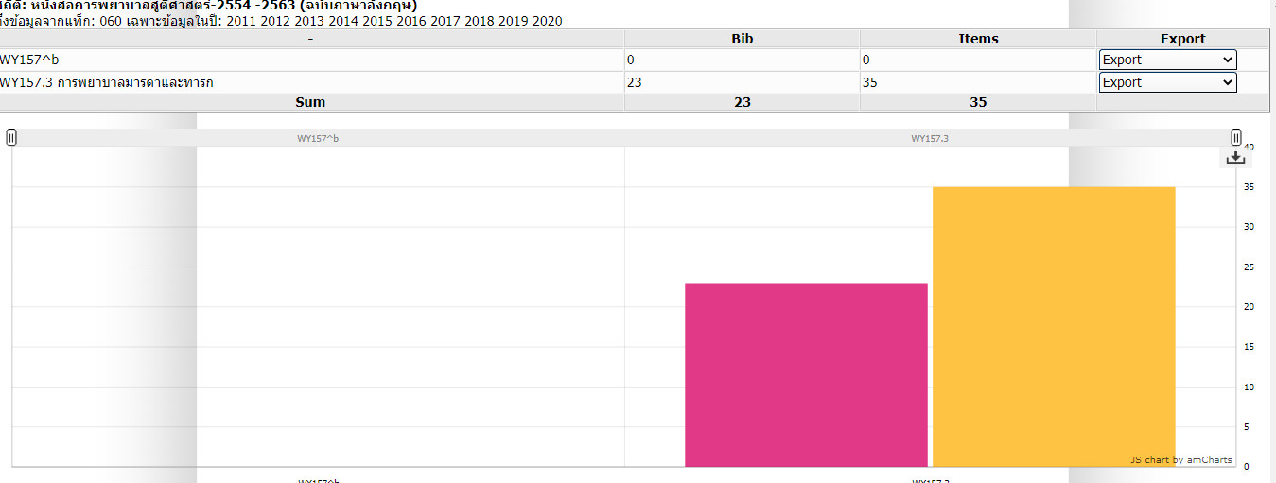

สถิติ: หนังสือการพยาบาลสูติศาสตร์-2554 -2563 (ฉบับภาษาอังกฤษ)
ดึงข้อมูลจากแท็ก: 060 ด้วย WY157.3 เฉพาะข้อมูลในปี: 2011 2012 2013 2014 2015 2016 2017 2018 2019 2020
23 Bib 35 Items
การพยาบาลสูติศาสตร์
ลำดับ | เลขหมู่ | รายการ | ผู้แต่ง | ปีพิมพ์ | จำนวน
1 | WY157.3 W585F 2011 | White, L., & .Duncan, G. (2011. ). Foundations of maternal & pediatric nursing (3rd ed.). United States : Delmar Cengage Learning. | Lois White, Gena Duncan, Wendy Baumle | 2011 | 1
2 | WY157.3 M425 2012 | Lowdermilk, D. L., Perry, S. E., & Cashion, K. (Eds.). (2012). Maternity & women’s health care (10th ed.). St. Louis : Elsevier Mosby. | Deitra Leonard Lowdermilk et al, editors | 2012 | 1
3 | WY157.3 C881S 2012 | Coyne, P. D. (2012). Schaum’s outlines maternal-newborn nursing. New York : McGraw Hill. | Patricia D. Coyne | 2012 | 1
4 | WY157.3 L527M 2012 | Leifer, G. (2012). Maternity nursing : an introductory text (11th ed.). St. Louis, Mo. : Elsevier/Saunders. | Gloria Leifer | 2012 | 1
5 | WY157.3 M425R 2013 | McKinney, E. S. (2013). Maternal-child nursing (4th ed.).  St. Louis : Elsevier/Saunders. | Emily Slone McKinney et al. | 2013 | 1
6 | WY157.3 R491M 2013 | Ricci, S. S., Kyle, T., & Carman, S. (2013). Maternity and pediatric nursing (2nd ed.). Philadelphia : Wolters Kluwer Health/Lippincott Williams & Wilkins. | Susan Scott Ricci,Terri Kyle, Susan Carman | 2013 | 1
7 | WY157.3 L781 2013 | Littleton, L. Y., & Engebretson, J. (2013). Maternity nursing care (2nd ed.). Clifton Park, NY : Delmar, Cengage Learning. | Lynna Y. Littleton-Gibbs, JoanC. Engebretson | 2013 | 1
8 | WY157.3 M425P 2014 | Perry, S. E., et al. (2014). Maternal child nursing care (5th ed.). Maryland Heights : Mosby Elsevier. | Shannon E. Perry, et al. | 2014 | 3
9 | WY157.3 M425 2014 | Lowdermilk, D. L., Perry , S. E., & Cashion , K. (Eds.). (2014). Maternity nursing (8th rev. ed.).Maryland Heights, MO : Mosby/Elsevier. | Deitra Leonard Lowdermilk, Shannon E. Perry, Kitty Cashion, editors | 2014 | 1
10 | WY157.3 P445 2014 | Simpson, K. R., & Creehan , P .A. (Eds.). (2014). Perinatal nursing (4th ed). Philadelphia : Wolters Kluwer/Lippincott Williams &Wilkins Health. | Kathleen Rice Simpson, Patricia A. Creehan | 2014 | 1
11 | WY157.3 C737 2014 | Kenner, C., & Lot, J .W. (Eds.). (2014). Comprehensive neonatal nursing care (5th ed.).New York : Springer Publishing Company. | Carole Kenner, Judy Wright Lot, editors | 2014 | 1
12 | WY157.3 D253O 2014 | Davidson, M. R., Davidson, M. R., & Wieland Ladewig, P. A. (Eds.). (2014). Olds maternal-newborn & women s health across the lifespan (9th ed.). Upper Saddle River, N.J. : Pearson Prentice Hall. | Michele R. Davidson, Marcia L. London, Patricia A. Wieland Ladewig, editors | 2014 | 3
13 | WY157.3 J67S 2014 | Johnson, J. Y., Boyd-Davis, E., & Taylor, P. C. (2014). Study guide for maternal & child health nursing : care of the childbearing & childrearing family (7th ed.). Philadelphia : Wolters Kluwer Health/Lippincott Williams & Wilkins. | Joyce Young Johnson, Edna Boyd-Davis, Penny C. Taylor | 2014 | 1
14 | WY157.3 P641m 2014 | Pillitteri, A. (2014). Maternal & child health nursing : care of the childbearing & childrearing family (7th ed.). Philadelphia : Wolters Kluwer Health/Lippincott Williams& Wilkins. | Adele Pillitteri | 2014 | 1
15 | WY157.3 M87 2014 | Murray, S. S., & McKinney, E. S. (2014). Foundations of maternal-newborn and women's health nursing (6th ed.). St Louis : Elsevier Saunders. | Sharon Smith Murray, Emily Slone Mckinney | 2014 | 6
16 | WY157.3 L527 2015 | Leifer, G. (2015). Introduction to maternity & pediatric nursing (7th ed). St. Louis : Elsevier/Saunders. | Gloria Leifer | 2015 | 1
17 | WY157.3 C797 2015 | Verklan, M. T., & Walden , M. (Eds.). (2015). Core curriculum for neonatal intensive care nursing (5th ed.).St. Louis : Saunders Elsevier. | M. Terese Verklan, Marlene Walden. | 2015 | 4
18 | WY157.3 M427 2015 | Butkus, S. C. (Ed.). (2015). Maternal-neonatal nursing made incredibly easy! (3rd ed.). Philadelphia : Wolters Kluwer. | Stephanie C. Butkus, editor | 2015 | 1
19 | WY157.3 C797 2016 | Mattson, S., & Smith, J. E. (Eds.). (2016). Core curriculum for maternal-newborn nursing (5th ed.). Saint Louis, MO : Saunders/Elsevier. | Susan Mattson, Judy E. Smith, editors | 2016 | 1
20 | WY157.3 M425 2016 | Lowdermilk, D. L., Perry, S. E., Cashion, K., Alden, K. R., Olshansky, E. F. (Eds.). (2016). Maternity and women’s health care (11th ed.). St. Louis, MO : Elsevier . | Deitra Leonard Lowdermilk, Shannon E. Perry, Kitty Cashion, Kathryn Rhodes Alden, Ellen F. Olshansky, editors | 2016 | 1
21 | WY157.3 N85 2017 | Nursing key topics review : Maternity. (2017). St Louis, Missouri : Elsevier. |  | 2017 | 1
22 | WY157.3 L527I 2019 | Leifer, G. (2019). Introduction to maternity and pediatric nursing (8th ed.).St. Louis, Mo. : Elsevier. | Gloria Leifer | 2019 | 1
23 | WY157.3 M425 2020 | Lowdermilk, D. L., Perrt, S. E., Cashion, K., Alden, K. R., & Olshansky, E. F. (Eds.). (2020). Maternity & women s health care (12th ed.). St. Louis, Missouri : Elsevier Mosby.. | Deitra Leonard Lowdermilk et al, editors | 2020 | 1

